

Assignment 1 Specification SWE5204

Advanced Databases and Big Data

|  |  |  |  |  |  |
| --- | --- | --- | --- | --- | --- |
| Course/Program | BEng Software Engineering & BSc (Hons) Computing | | | | |
| Module Name | SWE5204: Advanced Database and Big Data | | | | |
| Assessment Number | 1 of 2 | | | | |
| Assessment Type (and weighting) | Portfolio Component (50% of overall mark) | | | | |
| Assessment Name | Emerging and multi-paradigm database solution | | | | |
| Issue Date | w/c 09/10/23 | | | | |
| Assessment Submission Date |  | Assessment item | Due Date | Weight |  |
| Assignment 1 of 2 | 10/11/23 23:59 | *50%* |  |

## Learning Outcomes Assessed

**LO1:** Evaluate new and emerging developments in database technologies.

**LO2:** Compare and contrast multi-paradigm solutions to domain-specific database constructs.

Scenario:

Bolton Software Ltd is well known for building database systems. You have joined them as a junior database developer. Recently, Bolton Software is working with an auction house company called Bolton Auction House and are requiring a newly designed information management system.

Bolton Auction House has been operating for several years offering daily antique auctions, currently there is only one auction on any given day, however, demand shows that if they had a more efficient system in place, they could possibly run several auctions per day, more lots per auction, the director is also considering converting the manual auction to an online auction Some of the auction details are currently kept on a spreadsheet and all other details are entered manually into a paper form.

The process of the auction involves:

An individual item or group of items to be auctioned as one is known as a ‘LOT’. Each lot has a

reserve price and cannot be sold below this price.

Sellers’s place individual lots for sale by depositing their items at the auction warehouse at any time up to 2 weeks before the auction. Warehouse staff fill in a form including the seller’s name and address and for each lot a description, reserve price, and the date of the auction. Lot numbers are allocated by the warehouse staff as they come in. For each Auction they begin at 1 and have never yet exceeded 100. A sticker is attached to each lot to identify it. A seller is currently charged 10% commission on all lots sold and no other charges are made.

On the day of the auction, as bidders arrive, they hand in a deposit cheque for £100 and are given a numbered plaque which they hold up to place a bid. Bidders, especially dealers, can and do buy many lots. The plaque number allocated to each bidder is recorded manually on the spreadsheet.

An auctioneer conducts the auction and is supported by at least one assistant. They work through an auction lot list, compiled by the warehouse staff, with details of each lot including reserve price, in lot number order. There is a column in the spreadsheet for the auctioneer to add the successful bidder’s number and the final price if the lot is sold.

At the end of the auction, bidders’ hand in their plaques to the assistant and if they have successful bids, they leave their personal details and confirm the lots they have purchased as well as settling the bill (with the deduction of the £100 deposit) and arrange collection or delivery. If they have not made a purchase, they receive their deposit cheque back.

The proposed system requires the following functionalities.

* To be adaptable to the growth of the company (to allow several auctions per day and more lots per auction)
* To have appropriate database systems to meet the expansion plan of the company (the conversion of the manual auction process to an online auction site)
* To have modern database systems that are scalable and capable of storing various types of data.
* To visualise the system performance
* To have the solution to handle various types of databases systems.

# Portfolio Component 1: Create and compare databases (25% of overall Mark)

The company is currently using a spreadsheet to perform their daily tasks that includes the tracking of auctions, lots, and purchases etc. However, with the rapid growth of the company and the intention to move to a digital auction site it is expected that data may come in various formats, shapes, and speed, which may require to deploy different types of database systems like NoSQL or a RDBMS. The company needs you to create prototype database model in RDBMS and NoSQL.

An ERD has been provided for the purpose of building prototype database systems, see below.

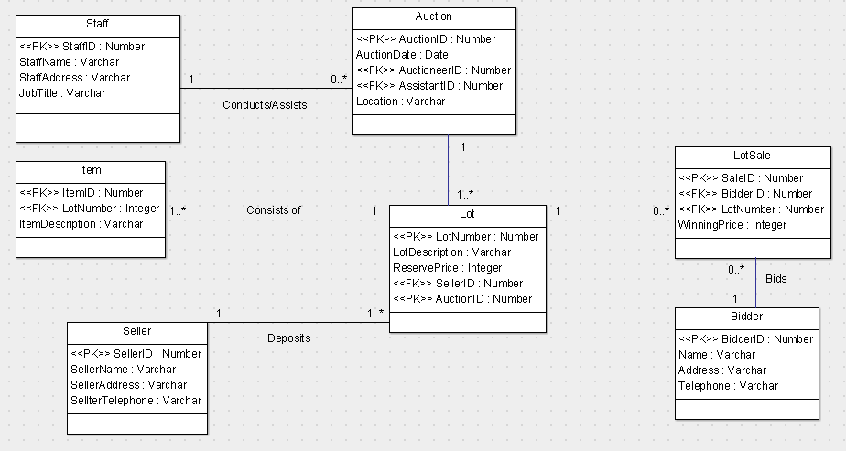

Figure 1: Bolton Auction House ERD

You are asked to create a SQL and NoSQL database using the ERD above.

1. Create an SQL script using MySQL Workbench or SQLite Studio and insert the data provided in Moodle (Ass1_Insert.sql)
2. Create a NoSQL database in MongoDB using a similar ERD and the same data as in the SQL script. Since MongoDB is different from SQL you may want to improve/adapt the entities during the design and development.
3. Run the following queries for your MySQL and MongoDB solution – you must provide a screenshot of each query when executed and provide the code in the appendices.
   1. Write a query to show any lots which contain items which are Toys, you must display the lot description and the date and location of the auction.
   2. Write a query to show seller name, telephone number, lot description and Reserve Price, where they have a lot where the reserve price is more than £90 but less than £150 and only being auctioned in Manchester.
   3. Write a query to show which customer has paid the highest total price for all successful bids, you should display the bidders name which should be labelled "Bidders Name" and the total price, which should be named as "Total Price".
   4. Write a query to show the total number of successful bids per customer and their name, rename the total number of bids as "Total Bids".
   5. Write a query to show the lowest reserve price for a seller, rename this column "Lowest Reserve Price" and show the sellers name, rename this column as "Seller Name".
   6. Write 2 new queries and run each one in MySQL and MongoDB, it is expected that you will use advanced features and explain the purpose of each query.
4. Write a report of 2000 words for the Company Director (including diagrams – screenshots of tables/collections, and queries for each design analysing and distinguishes between RDBMS and NoSQL. This report should reflect your experience to find a solution to the company’s current systems and future solutions as well as including research evidence to back up your arguments from appropriate resources, this must include a conclusion of which type of database would be best suited with justifications.

Your report must also include a comparison of your query experience for both solutions and explain how these queries (MySQL and MongoDB) are similar/different to each other. You may want to explain how your design helped/did not help, were the designs for each type of database identical or did you have to modify the design etc. Be sure to include screenshots of the query results.

Portfolio Component 1, part 4 will contain elements which are unique and individual to you and your experience only, this will provide evidence that this is your own work.

The report must be in MS Word. The report should contain all the diagrams with a brief explanation or justification.

Source Code: The SQL script, MongoDB code and all query syntax should be added to the end of the report as appendices (should not include in the word count) as well as submitted as a zipped folder in Moodle in the relevant submission folder.

Expected Number of Sources: The report should have at least 5 references of which 3 should be relevant peer-reviewed journal/ conference papers.

# Portfolio Component 2: Emerging Database Technologies (25% of overall mark)

The company wants to deploy a better database system to adapt to the current trend of technology to provide better service to their customers and sellers. So, they want to identify the current trend and emerging database technologies to apply in their future information system other than the information you have previously researched (MongoDB and MySQL).

Write a whitepaper on current and emerging database technologies. Evaluate new and emerging database technologies to meet the company’s current and future needs. The aim of the paper should inform the Company Director and other technical personnel of Bolton Auction House about various current and emerging database technologies.

Avoid duplicating your research as you have analysed and compared RDBMS (MySQL) and NoSQL (MongoDB – document based) for component 1, you could consider other types of NoSQL databases which are not document based as well as considering other emerging database technologies.

Word Count: The whitepaper should have a word count of 2000 words.

Expected Number of Sources: The white paper should have at least 10 references of which 3 should be relevant peer-reviewed journal/ conference papers.

Secondary Research Requirements:

Secondary research support is expected should be correctly cited using Harvard Referencing for both in-text citations and Reference Structure. For further details please see [https://leaponline.bolton.ac.uk/My-Academic-Development/My-Writing-](https://leaponline.bolton.ac.uk/My-Academic-Development/My-Writing-Techniques/Referencing/Level-2/Harvard-Referencing.aspx) [Techniques/Referencing/Level-2/Harvard-Referencing.aspx](https://leaponline.bolton.ac.uk/My-Academic-Development/My-Writing-Techniques/Referencing/Level-2/Harvard-Referencing.aspx)

Submission: You must submit Task 1 and 2 in a single (MS Word) document through the appropriate Moodle Turnitin link by 23:59 on 10 November 2023. You must include a zipped folder of your SQL and MongoDB code and queries through the Moodle Code Submission folder by 23:59 on 10 November 2023.

Grading

A percentage mark will be provided based on *General Assessment Guidelines for Written Assessments*. Grading is as follows:

|  |  |
| --- | --- |
| A: | 70 - 100% |
| B: | 60 - 69% |
| C: | 50 - 59% |

D: 40 - 49%

Marks below 40% will be classed as fail.

Specific Assessment Criteria:

(Please note that the General Assessment Criteria will also apply)

70% and above

* Having performed an excellent investigation, understanding, and implemented multi- paradigm databases for domain-specific problem.
* Critically analysed the solution clearly and critically provide a justified conclusion.
* Have provided an excellent review of the theories relating to the emerging database technologies and demonstrate excellent understanding.
* Extensive research demonstrating the use of a range of current and quality secondary research resources.

60%- 69

* Having performed a comprehensive investigation, understanding, and implemented multi-paradigm databases for domain-specific problem.
* Cleary analysed the solution and provided a justified conclusion.
* Have provided a comprehensive review of the theories relating to the emerging database technologies and demonstrate comprehensive understanding.
* Research demonstrating use of a wide range of current and quality secondary research resources.

50%- 59

* Demonstrates a sound investigation, understanding and implemented multi-paradigm databases for domain-specific problem.
* Presents a logical analysis to the solution and provide a justified conclusion.
* Demonstrates a sound and breadth review of the theories relating to the emerging database technologies and understanding.
* Research demonstrating use of a range of relevant current and quality secondary research resources.

40%- 49

* Demonstrates a sufficient investigation, understanding and implemented multi- paradigm databases for domain-specific problem.
* Presents a valid analysis to the solution and provide a sufficient conclusion.
* Demonstrates a sufficient review of the theories relating to the emerging database technologies and understanding.
* Research demonstrating use of limited relevant current and quality secondary research resources.

## Guidelines for the Preparation and Submission of Written Assessments

1. Written assessments should be word-processed in Arial or Calibri Light font size 12. There should be double-spacing and each page should be numbered.
2. There should be a title page identifying the programme name, module title, assessment title, your student number, your marking tutor and the date of submission.
3. You should include a word-count at the end of the assessment (excluding references, figures, tables and appendices).

Where a word limit is specified, the following penalty systems applies:

* + Up to 10% over the specified word length = no penalty
  + 10 – 20% over the specified indicative word length = 5 marks subtracted (but if the assessment would normally gain a pass mark, then the final mark to be no lower than the pass mark for the assessment).
  + More than 20% over the indicative word length = if the assessment would normally gain a pass mark or more, then the final mark will capped at the pass mark for the assessment.

1. All written work should be referenced using the standard University of Bolton referencing style : Harvard – see: <https://libguides.bolton.ac.uk/resources/referencing/>
2. Unless otherwise notified by your Module Tutor, electronic copies of assignments should be saved as word documents and uploaded into Turnitin via the Moodle class area. If you experience problems in uploading your work, then you must send an electronic copy of your assessment to your Module Tutor via email BEFORE the due date/time.
3. Please note that when you submit your work to Moodle, it will automatically be checked for matches against other electronic information, as well as for hidden text characters and AI generated text. You will be able to see similarity matches but not currently flags for hidden characters and AI-generated text. The outcomes of Turnitin reports may be used as evidence in an academic misconduct investigation (see Section 14).
4. Late work

Late work will be subject to the following penalties:

* + Up to 7 calendar days late = 10 marks subtracted but if the assignment would normally gain a pass mark, then the final mark to be no lower than the pass mark for the assignment.
  + More than 7 calendar days late = This will be counted as non-submission and no marks will be recorded.

Late submission of assessments on refer and those which are graded Pass/Fail only, is not permitted unless an extension is approved. See below.

1. Extensions

In the case of exceptional and unforeseen circumstances, an extension of up to 14 days after the assessment deadline may be requested using the standard University Extension

Request Form. For approval there would need to be an explanation and evidence of relevant circumstances.

Longer extensions for individual assessments, projects and artefacts may be granted, at the discretion of the Programme Leader.

Requests for extensions which take a submission date past the end of the module (normally week 15) must be made using the Mitigating Circumstances procedure.

Some students with registered disabilities will be eligible for revised submission deadlines. Revised submission deadlines for disability adjustments do not require the completion extension request paperwork. However, students should request these in writing in advance.

Please note that the failure of data storage systems is not considered to be a valid reason for an extension. It is therefore important that you keep multiple copies of your work on different storage devices before submitting it.

## 14. Academic Misconduct

Academic misconduct may be defined as any attempt by a student to gain an unfair advantage in any assessment. This includes plagiarism, collusion, commissioning (contract cheating) amongst other offences. In order to avoid these types of academic misconduct, you should ensure that all your work is your own and that sources are attributed using the correct referencing techniques. You can also check originality through *Turnitin.*

Please note that penalties apply if academic misconduct is proven. See the following link for further details:

[https://www.bolton.ac.uk/student-policy-zone/student-policies-2023-24/academic-](https://www.bolton.ac.uk/student-policy-zone/student-policies-2023-24/academic-misconduct-regulations-and-procedures-23-24) [misconduct-regulations-and-procedures-23-24](https://www.bolton.ac.uk/student-policy-zone/student-policies-2023-24/academic-misconduct-regulations-and-procedures-23-24)

General Assessment Guidelines for Written Assessments Level HE5

